F.4 Bio Ch.14 Transport of Substances and Support in Plants – Supplement Worksheet

Name: _____________________ ( ) F.4__ Date: ________________

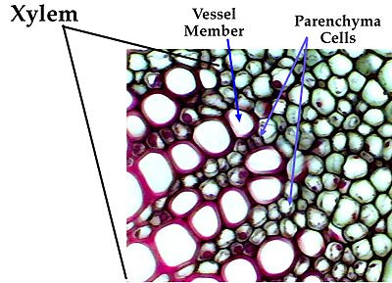
Xylem
vessels
fibres
Tracheids
(important in gymnosperms & ferns)
parenchyma

Transport of water and minerals

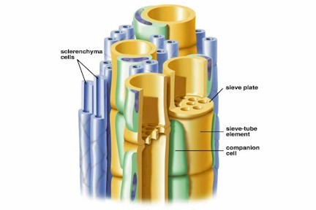
Phloem
Sieve tube elements
Phloem fibres
Companion cells
Phloem parenchyma
Sieve tubes
Translocation of food
Large nucleus,
many mitochondria
Assist translocation function of sieve tubes

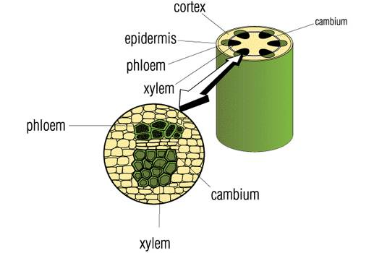

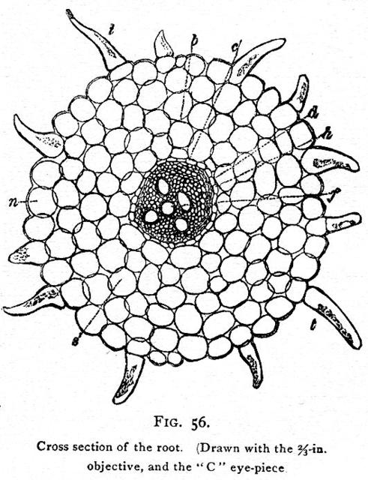

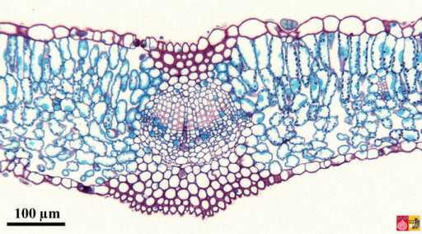

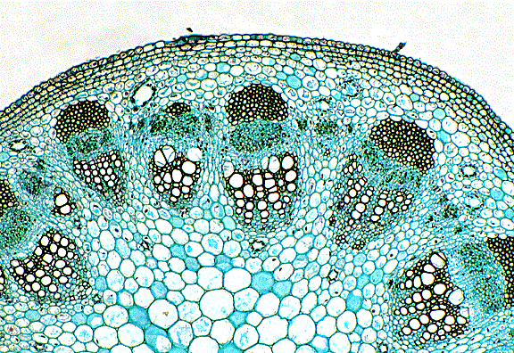
X.S. of a dicotyledonous stem
S
P
X
E
VC

